Application Form -
Denham Foreshore

Clearly mark location of proposed event boundaries. Client / Organisation Name: _______________________________

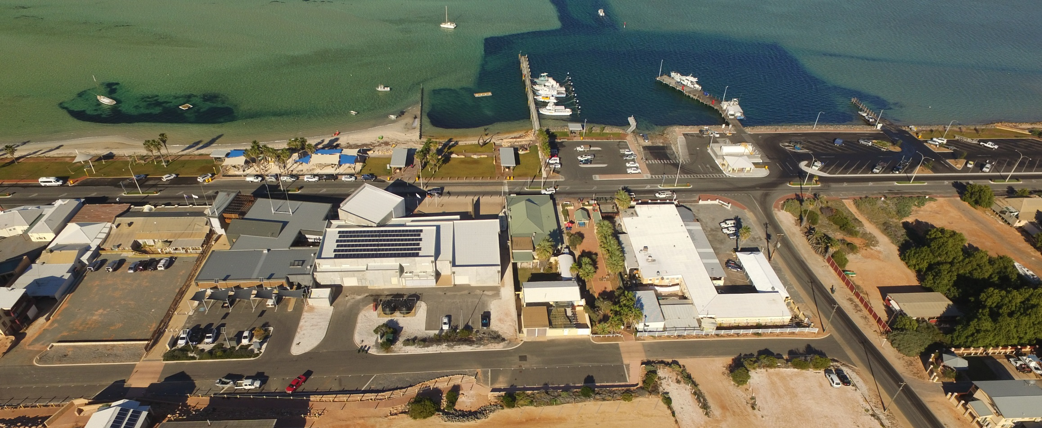

Knights Tce

Hughes St
St St
Brockman St

Application Form -
Denham Foreshore

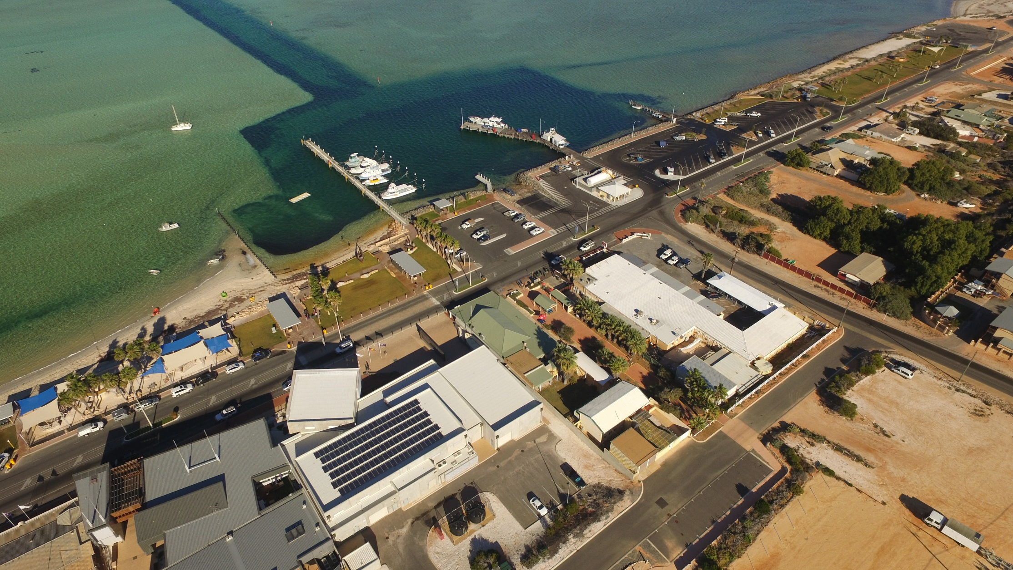
Clearly mark location of proposed event boundaries. Client / Organisation Name: _________________________________

Hughes St

Brockman St

Knights Tce
Application Form -
Denham Foreshore

Clearly mark location of proposed event boundaries. Client / Organisation Name: _________________________________

