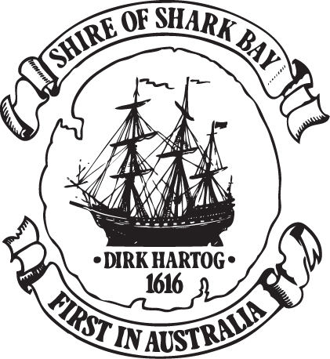

2:40pm Sunday 8 February 2026
ROAD CLOSURES - ADVANCED WARNING
From 6pm tonight the North-West Coastal Highway north of Geraldton will be CLOSED.
From 6pm tonight access to Shark Bay Road from the Overlander Roadhouse will be CLOSED.
Shark Bay is now under Cyclone Advice.

