|  |  |
| --- | --- |
|  | Shire of Shark Bay |

CROSSOVER APPLICATION AND REIMBURSEMENT

# Applicant Checklist

COMPLETE (TICK ☑)

1. Please contact Depot to prior to commencing works to arrange pre-start check with □

Works Manager. Depot Phone – 9948 1013 or email [works@sharkbay.wa.gov.au](mailto:works@sharkbay.wa.gov.au)

1. Works Manager completes the pre-start check list (Page 7) and applicant keeps □

form until completion.

1. Please contact Depot when ready for a Preparation Check with Works Manager. □

Works Manager will complete preparation check (Page 7).

Applicant keeps form until completion.

1. Please contact Depot once Crossover is complete to arrange a Completion Check □

with Works Manager. Works Manager will complete Completion Check (Page 7).

1. Once Completion check done, please submit the following to the Depot Administration for processing:

Completed Check List Sheet (Page 7) □  
Crossover Reimbursement Request Form (Page 8) □

Copies of your receipts □

**Shire of Shark Bay – Depot**

Email: [admin2@sharkbay.wa.gov.au](mailto:admin2@sharkbay.wa.gov.au)

Post: PO Box 126, Denham WA 6537

In Person: Dampier Road, Denham (Monday to Friday 7am-3.30pm)

Phone: 9948 1013

|  |  |
| --- | --- |
|  | Shire of Shark Bay |

CROSSOVER INFORMATION SHEET

A crossover is the part of the driveway that crosses over the verge area in front of a property, from the kerb line to the property boundary line.

# Driveway Crossovers

1. This drawing to be read and crossover to be constructed in accordance with standard crossover specification as per Loca
2. l Council Policy 9.1 (Page 3).
3. Crossovers to be constructed in 25 MPa concrete with F62 reinforced mesh.
4. Footpaths are located at the road kerb.
5. All crossovers must be inspected by Council staff during normal working hours prior to the pouring of concrete or laying of pavers.
6. Crossover obstructions – should any tree, power pole, sign, pit, manhole or any other obstruction be located on the proposed alignment of the crossover, the applicant shall be liable for the costs associated with the removal or alteration of the same.
7. Apron at 1.5 metre return of kerb or as per plan A or at the same level as the bitumen seal if the kerb is to be removed or as determined by Council.
8. Where a crossover cuts across a footpath Council will determine whether the footpath should be retained or removed.
9. Crossovers shall have a minimum grade of +2% and a maximum of +6% for the first 2.5m from the back of kerb. Where no kerb is present, the crossover is to tie into existing road shoulder and verge levels.
10. The crossover shall be at right angles to the road, a minimum of 6.0m from the tangent point of any corners and a minimum 1.5m from side boundary.
11. Properties abutting a road which is the responsibility of Main Roads WA shall also obtain approval from Main Roads WA.
12. Landowners shall obtain a Dial Before You Dig (1100) prior to commencing construction. Any damage to existing assets or services (including those underground) is the responsibility of the landowner.
13. Landowners are required to obtain approval from the relevant authority for any relocation or alterations to existing assts or services which are not the responsibility of the Shire. The Shire is not responsible for any costs related to the relocation or alteration of any assets or services.
14. Existing kerbing may only be removed with approval of the Shire. The extent of kerb to be removed will be confirmed by the Shire and the landowners are responsible for reinstating any removed kerb.
15. Unless approved in writing by the Shire, paths, street furniture and street trees cannot be removed for the purposes of constructing a crossover. Landowners will be responsible for all costs associated with removal of paths, street furniture and trees. If approval is not granted, landowners will be responsible for the repairs to any damaged paths
16. The landowners are responsible for leaving the site in a clean state, free of debris, spoil and trip hazards.
17. Surplus materials (including acids) are not to be disposed of on Shire verges, reserves, open drains or washed down drainage pits. Any evidence of this practice will require the landowner or contractor to remove the disposed concrete at their cost.
18. Traffic Management may be required and, if required, will be stipulated as a condition of the crossover approval.

Council Policy

9.1 Crossovers

Purpose

To set out what constitutes a ‘standard crossing’ from the paved portion of a road to a property boundary for use by vehicles.

Detail

1. A standard crossing comprises either -
   1. A 150 mm compacted and water bound road base driveway, sealed with two coat of bitumen and topped with an approved aggregate; or
   2. A minimum of 100 mm reinformed concrete over a compacted sub-base; or
   3. A minimum of 50 mm thick brick pavers; or
   4. As approved by Council
2. A crossing must be built from the paved portion of a road or kerb to the front boundary line and tied in or made contiguous with abutting structures (kerbs, footpaths and driveways).
3. The minimum width of the standard crossing shall be 3.0 metres for residences, 4.0 metres for commercial, 6.0 metres for light industrial, 6.0 metres for heavy industrial and 7.5 metres for service stations each with a 1.5 metre radius “fishtail” onto the kerb line.
4. The gradient shall be positive 2% for the first 1.5 metres from the kerb line.
5. The Shire of Shark Bay will contribute to one crossing per property only.
6. Where the ratepayer elects to construct a crossover, the Shire’s contribution shall not exceed 50% of the cost of the crossover as defined in this policy and as listed in the Shire’s Fees and Charges Schedule of its annual budget. The square metres calculated shall be the length (from the road kerb to the property line) multiplied by the nominal width. The applicant must produce documents stating the full cost of the crossing.

Applicable legislation

|  |  |
| --- | --- |
| Act |  |
| Regulation | Regulation 15 of the Local Government (Uniform Local Provisions) Regulations 1996 |
| Local Law | Clauses 2.4 and 2.5 of the Shire of Shark Bay Activities on Thoroughfares Local Law relate to temporary crossovers, and removal of redundant crossovers |
| Other |  |

|  |  |
| --- | --- |
| Adopted by Council on: | 27 August 2014 |

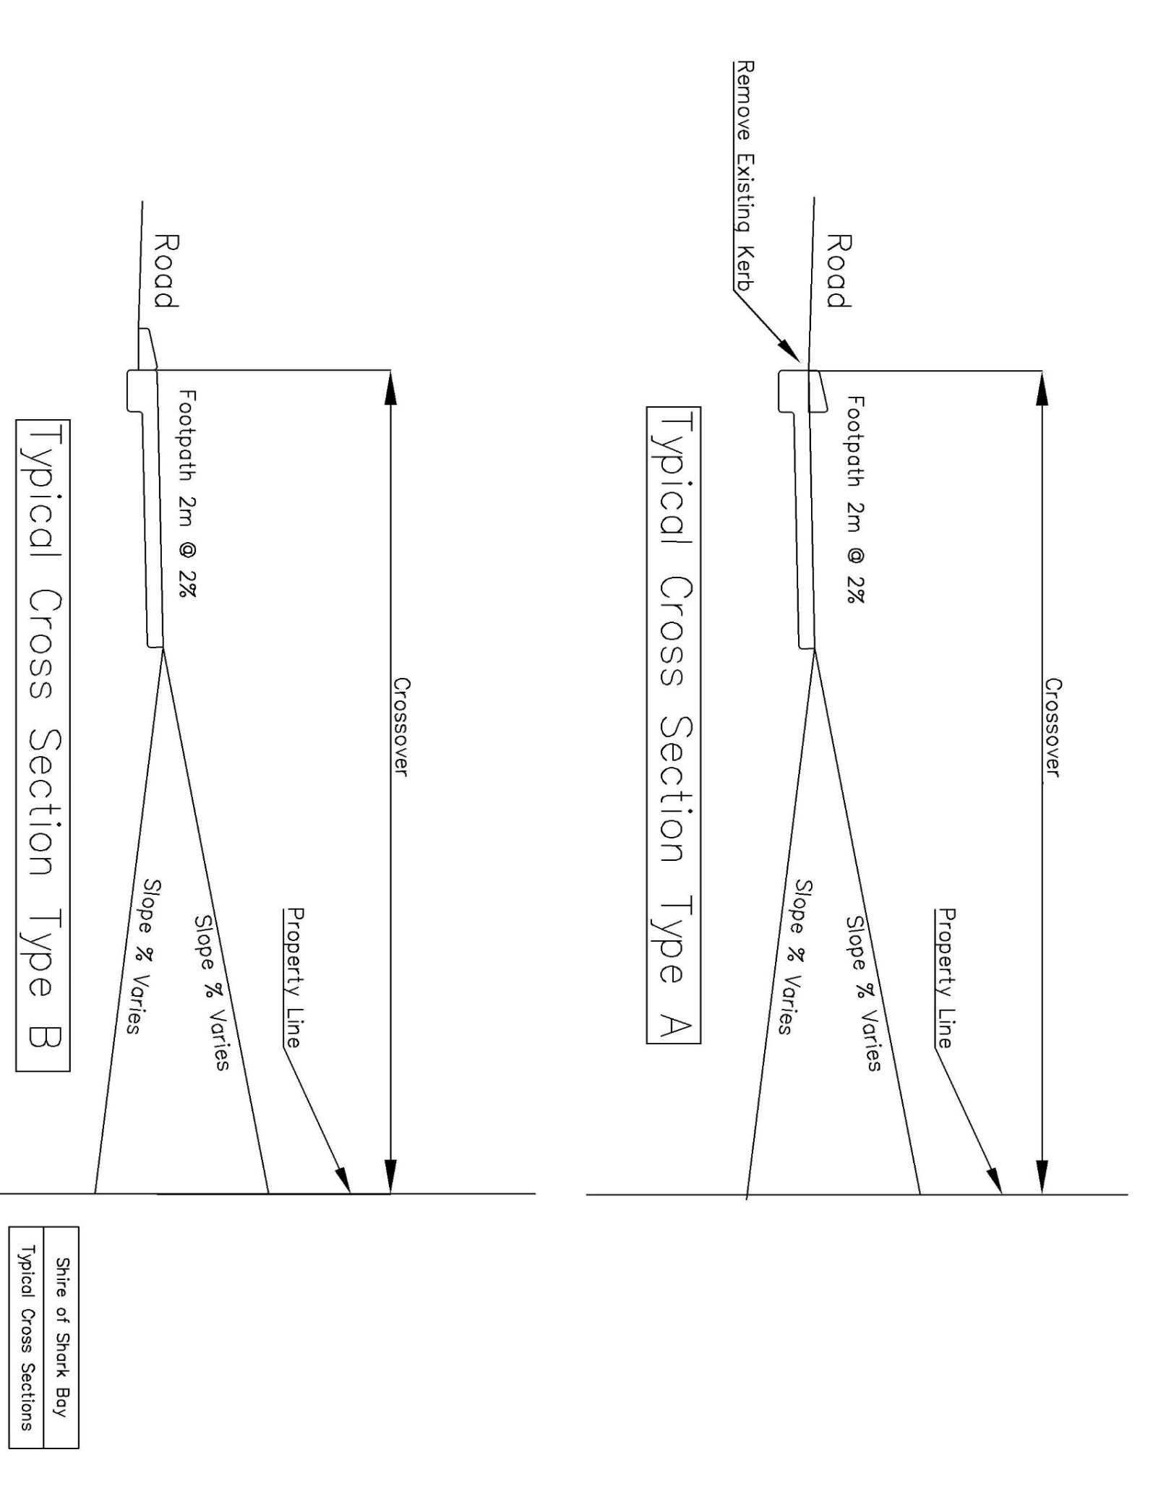



**SHIRE OF SHARK BAY**



**CREDITOR ADDITION / AMENDMENT FORM**

|  |  |  |  |  |
| --- | --- | --- | --- | --- |
| Name | |  | | |
| Company Name (if applicable) | |  | | |
| ABN (if applicable) | |  | | |
| Postal Address | |  | | |
| Phone | |  | | |
| Email address | |  | | |
| Contact Person | |  | | |
| BSB: |  | | Account #: |  | |
| Account Name (if different from above) | | | | | |
| Signed | | | | | |
| DETAILS OF AMENDMENT: | | | | | |
|  | | | | | |
| **OFFICE USE ONLY:** | | | | | |
| CREDITOR NUMBER | |  | | |
| CREDITOR AUTHORISATION RECEIVED | |  | | |
| ABN VERIFICATION | |  | | |
| BANKING DETAILS CONFIRMED | |  | | |
| CREATED / AMENDED BY | |  | | |
| REQUESTED BY | |  | | |
| **AUDIT:** | | | | | |
| DATE | |  | | |
| ENTERED BY | |  | | |
| REVIEWED BY | |  | | |
|  | |  | | |

**Crossover Reimbursement Request**

Once crossover is finished and final inspection has been completed by the Shire Works Manager, please submit this form with your Crossover Inspection Form and copies of receipts

**Company/Name___________________________________________**

**Address_________________________________________________**

**ABN____________________________________________________**

**Phone________________Email______________________________**

**Bank Details: BSB_________Account Number ________________**

**Contact Person __________________________________________**

**Signature_______________________________________________________________________________________________________________________**

**Office use**:

☐ Final Inspection Complete and Inspection Form signed off by Works Manager

☐ Receipts Provided

Property Number ___________ Synergy Record Number ___________________

Total Crossover Cost ___________Total Reimbursement to be provided by Shire__________

Approved by Works Manager (Signature) ______________________Date _______________

☐ Payment Processed

Creditors Code______________________

Entered By: ________________________ Signature: _________________ Date _________

Reimbursement

Width of Crossover_______ X Length of Crossover_____ Equals ________ Add Fish Tails____ Equals Total______

Reimbursement is Half of the Total Area _____ X Cost as per the Fees and Charges $_____ Equals $ ________

Or Half of the Invoice provided, whichever is the lesser

Widths

Residence 3.0 Metres

Commercial 4.0 Metres

Light/Heavy Industrial 6.0 Metres

Service Stations 7.5 Metres